**Lab 4 Parts A, B**

1. The following sequence diagram is incomplete. Re-draw the diagram so that it follows UML synatx rules.

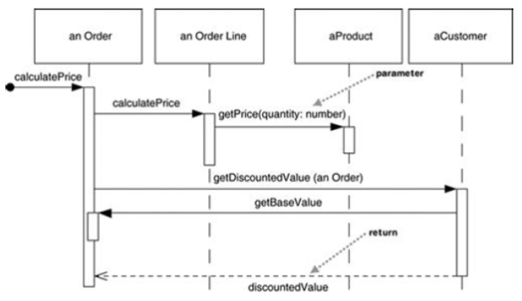

In your diagram, do the following:

* Include message numbering
* Use proper UML syntax for the objects displayed at the top.
* Incidate looping wherever it occurs with Iteration markers

1. Create a sequence diagram based on the flow that occurs when an actor invokes the checkoutBook() method on CheckoutForm

//FROM CLASS CheckoutForm

public void checkoutBook() {

theCheckoutController.checkoutBook(m_book, m_member);

displayCheckoutInfo();

clearCheckoutFields();

}

//FROM CLASS CheckoutController

public void checkoutBook(Book book, LibraryMember member) {

CheckoutRecord aCheckoutRecord = new CheckoutRecord();

aCheckoutRecord.setDueDate(member.getCheckoutPeriod());

aCheckoutRecord.addBook( book );

member.addCheckoutRecord( aCheckoutRecord );

theILibraryDBSubsystem.addCheckoutRecord(member.getMemberID(),

aCheckoutRecord);

}